2
Brief History of 3D Printing
Origin
Creation of the first commercial 3D printer is generally attributed to Charles W. Hull and the company 3D Systems in 1986. Hull coined (and patented) the term “stereolithography” which refers to the process of making solid objects by “printing” thin layers of ultraviolet curable material one on top of another (used genetically today to refer to any “additive” 3D printing process, not just cured resin printers).

The idea of creating (or recreating) solid objects from stacking layers or slices can be traced back as far as 1860. Early attempts at applying these ideas to the manufacturing process can be found as far back as 1956, with the use of lasers and photo polymers in the 1970s. However, much of the robotics and computer technology necessary to control the process was not commercially practical until the 1980's with the mainstream availability of microprocessor control systems.

By combining microprocessor control to the stereolithography process, Hull was able to design a machine that could be practical and inexpensive enough (in relative terms) to be used outside of the research lab and inside commercial and higher-education environments.

Industrial Use
Early industrial (non-experimental) applications for 3D printing focused primarily in the area of research and design. These machines ushered in the era of “rapid prototyping”, allowing designers and engineers to produce physical models of designs in hours instead of weeks, without the aid of skilled craftspeople and machinists.

<image of early commercial 3d printer>

These early machines cost tens or hundreds of thousands of dollars to acquire and thousands of dollars annually to operate. They used proprietary materials that were available only from the original equipment manufacturer (OEM) and often required maintenance contracts that ensured ongoing cost to operate (and revenue for the OEM). This arrangement is very similar to how early computer systems were used, before the advent personal computer.

Through the 1990's, rapid prototyping changed the way that product research and development was carried out in industrial environments. As the technology evolved, the practicality and costs decreased enough to make these devices practical in the University environment as well. However, due to the specialized nature of the applications for these machines, as well as the small number of companies manufacturing them, their cost remained in the tens-of-thousands-of-dollars range, so in turn the applications for this technology were limited to areas where their cost could be justified. This self-stoking cycle would remain intact until 2005.

The RepRap Project
In 2005, Dr. Adrian Bowyer began The RepRap Project with the goal of creating a 3d printer that was capable of printing copies of itself. Dr. Bowyer had experienced the awesome power of 3d printing at the University of Bath, and realized the potential for these machines if they were made available outside of the University laboratory or corporate R&D department, but up until this point 3d printers were so expensive to purchase and operate that only the largest companies and university’s could afford them.

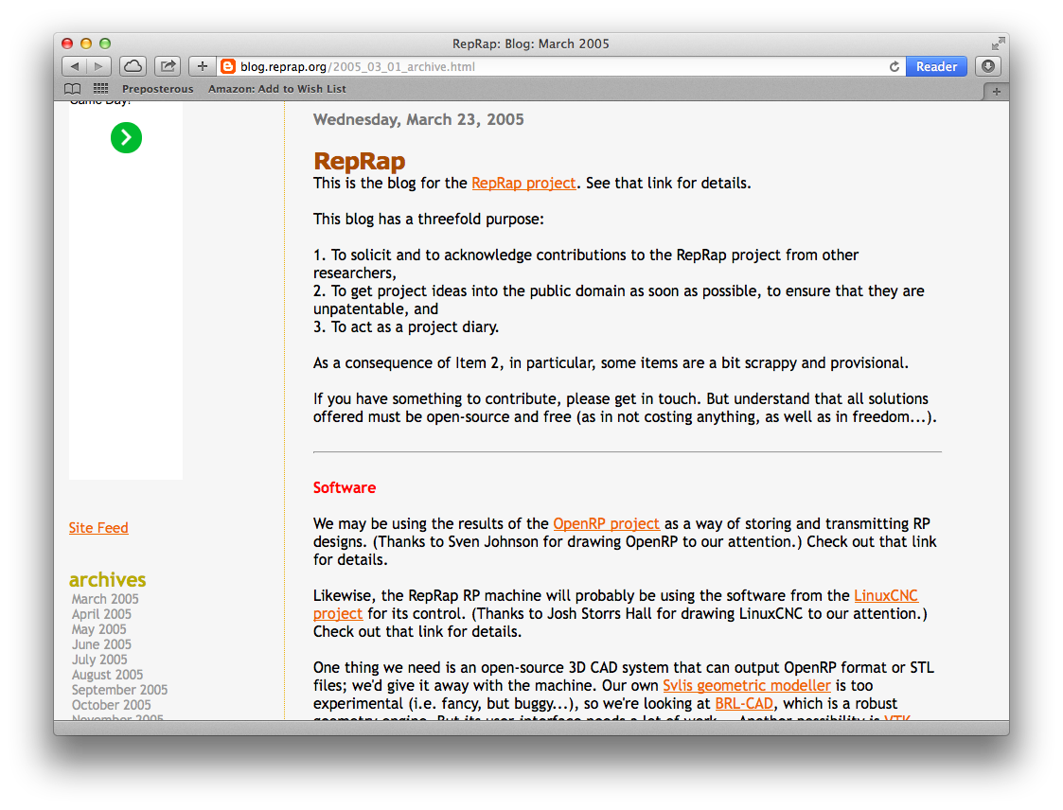Illustration 1: The first entry in the Reprap Project blog (2005)

By designing the machine to self-replicate, the cost of each generation goes down as the quality of the output of each generation goes up.

In addition to self-replication, every RepRap design would be made Open Source, allowing anyone to copy, modify and distribute these machines in any way they see fit. This was a radical shift from the existing machines whose technology was a closely-guarded secret protected by intellectual property laws.

By providing the RepRap designs as Open Source, and carrying-out the development of the machine out in the open, The RepRap Project was able to quickly create their first generation printer (Darwin) within three years, and a second-generation machine only one year later. This was possible because the open nature of the project encouraged anyone interested in the project to contribute, and as replicas of the original Darwin began to appear around the world, people using them found new ways to improve their machines and in turn contributed these improvements to the overall project.

Today there are numerous descendants from the original RepRap Darwin design, some are simply improvements on the original design, others have evolved into specialized machines that focus on producing parts with particular qualities but all can be related directly back to the original printer designed for the RepRap Project, and in fact most “consumer grade” 3d printers, whether they are RepRaps or not, are descended from this original design.

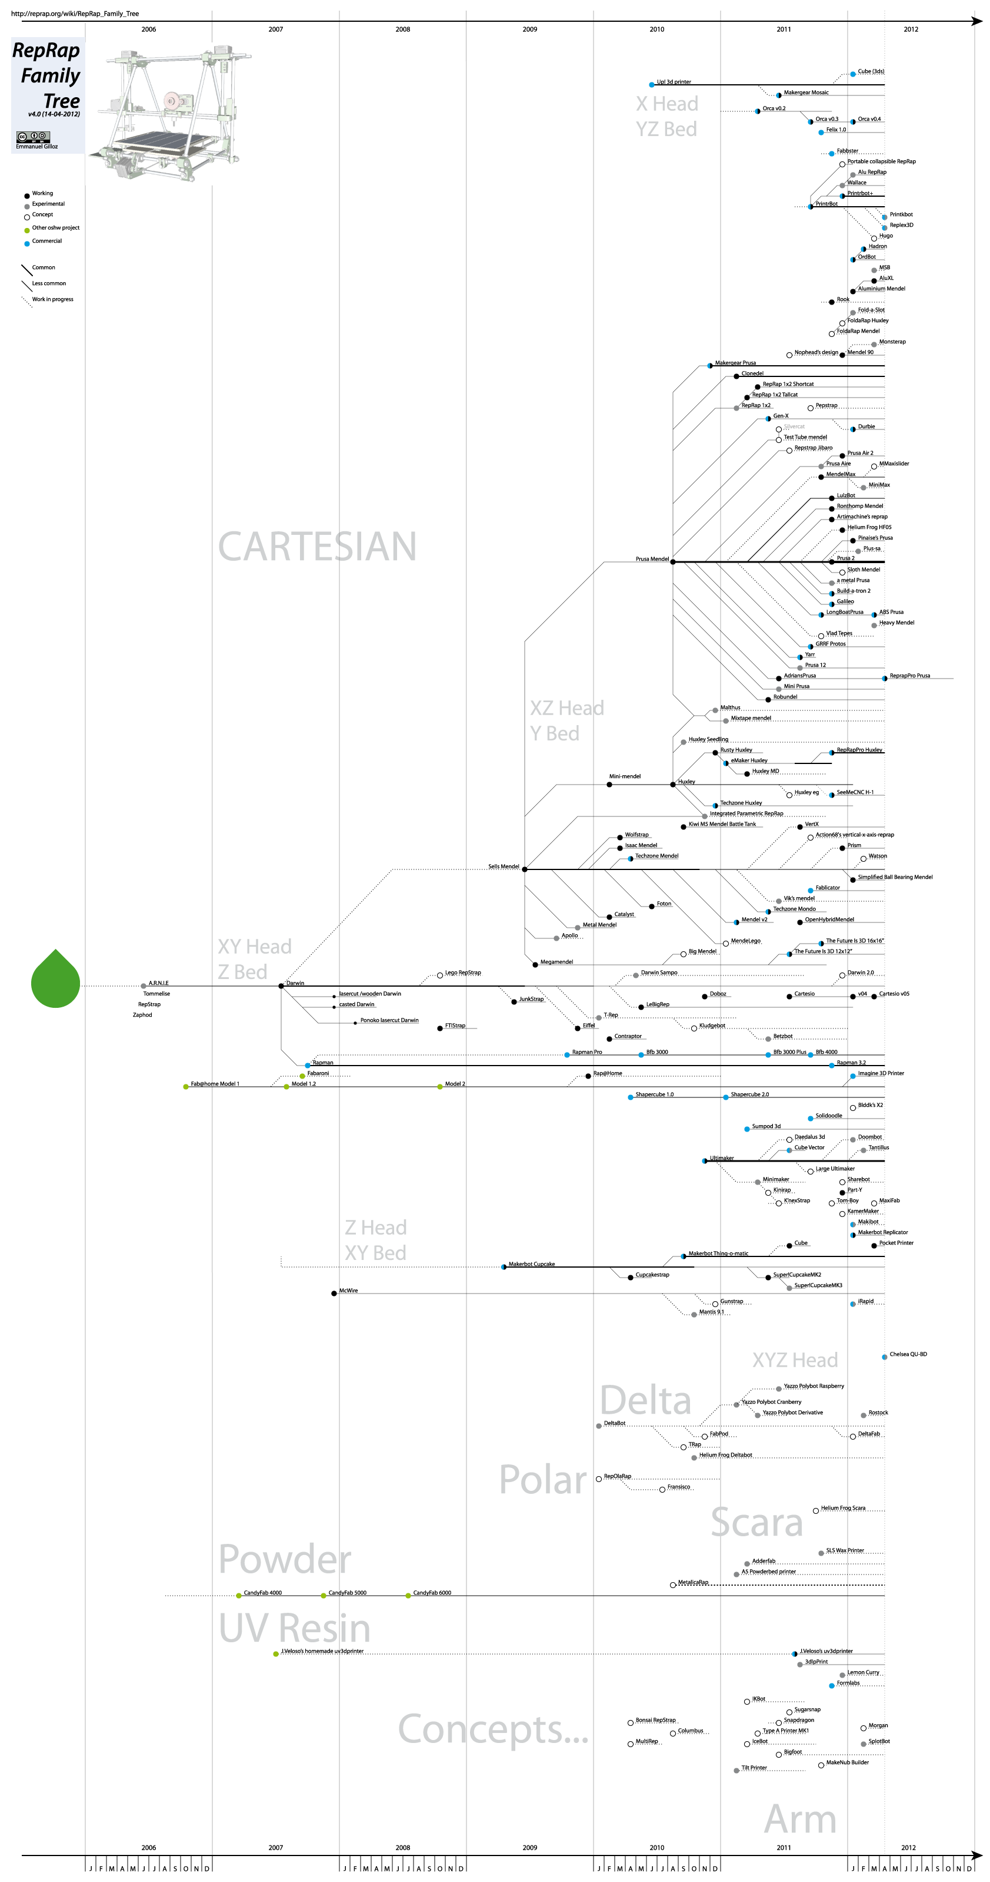Illustration 2: The Reprap family tree (as of early 2014)

Desktop Manufacturing
With the introduction of the Reprap came the possibility of Desktop Manufacturing. Desktop Manufacturing refers to the capability to contain the entire manufacturing process for an object within the physical (and to some degree, financial) constraints of the typical desktop environment.

This term is in-kind with Desktop Publishing, which emerged in the 1980's as it became possible to replicate the output of a complete print publishing system (traditionally a “Print Shop”) through to the invention of WYSIWYG page layout software and sub-$5000.00 laser printers.

The combination of inexpensive 3D modeling software and Reprap 3D printing technology made possible for the first time the ability for a typical home operator to design and manufacture a physical object with no specialized tooling or skills for less than $5000.00. Additionally, due to the foresight of the Reprap Project's open-source licensing, many of these Desktop Manufacturing pioneers used this capability to produce additional Reprap printers as well as continual improvements to the design, further reducing the cost of entry for future Desktop Manufacturers.

3D Printing Today
At the time of this books writing, the average cost of a personal 3D printer is $1000.00; an amount often considered to be the threshold for mainstream adoption of new consumer technology.

Additionally, there are ready-to-use printers available for as little as $500.00, and printers in kit form as cheap as $200.00. Of course in keeping with Dr. Bowyer's vision, a sufficiently-motivated individual could create their own printer “from scratch” for even less by connecting with the Reprap community, securing a set of printed Reprap parts and creatively scrounging up the remaining “minerals” necessary to build a printer of their own.

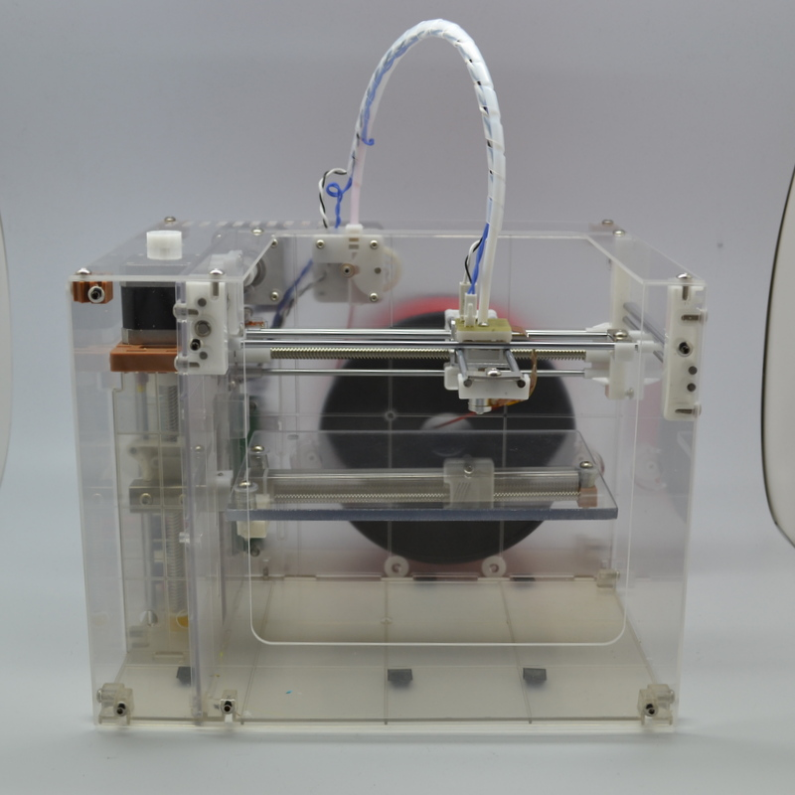Illustration 3: The $200 Makibox 3D printer
As Reprap designs evolve, some branches of the family tree focused on self-replication require fewer and fewer of these “minerals”, making Dr. Bowyer's dream more and more of a reality. Even components that seem impossible to print like motors and electronics are beginning to be realized by modifying their designs, inventing new technologies and adding capabilities to their parent printer's design.

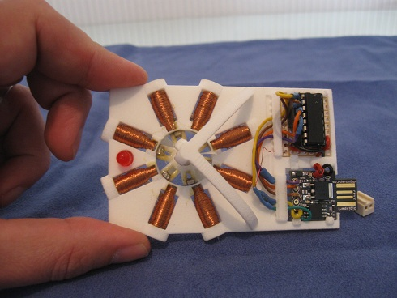Illustration 4: A printed "stepper motor", the heart of many Reprap designs

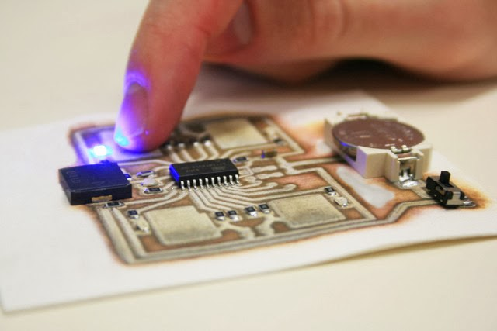Illustration 5: A complete circuit board printed by a Cartesian Corp. Ex printer

The capabilities needed for a 3d printer to self-replicate happen to cover the same areas needed to produce most modern consumer goods, so by setting this as the baseline goal of the Reprap project, the result is printers that not only can create copies of themselves, but create many other goods as well. As these printers replication capabilities increase, the range of other things they can produce increases exponentially. Ten years ago the idea of such a device was unimaginable by the general public, even though the foundations for such technology had existed for more than a century and had been in use for decades. By simply opening up the design, and establishing the goal of self-replication, the Reprap project (like the personal computer before it) made possible an era of invention and innovation that simply would not exist if 3D printing were to have remained under the lock and key of closed commercial use.

References:
Rapid Prototyping in Europe and Japan - http://www.wtec.org/pdf/rp_vi.pdf
3d printed stepper motor - http://www.shapeways.com/forum/index.php?t=msg&th=13766&start=0&
3d printed circuit - http://www.cartesianco.com

